**Web Technology for bioinformatics**

Name - Dharineesh K S Data - 15/09/2021

Regno - 123013012 Ex.no - 01

**Aim:**

To create a two column and three column layout using CSS coding styles.

**Box model calculation:**

The W3C box model considers the width of the element to be equal to the content of the box excluding its padding and border. Padding and border are added on top of whatever dimensions you set for the element, which could have some unpredictable consequences on your page layout.

For example, let’s consider a box with a width of 200px and a height of 200px, padding of 10px on all sides and a border of 2px all round. The browser does not see it simply as a 200px box. Rather, the browser calculates the horizontal space necessary to display the box as being 224px: 200 (width) + 2 (left border) + 10 (left padding) + 10 (right padding) + 2 (right border) = 224px. Given that the element is a perfect square, the height will also compute to 224px.

**General formulae:**

* Width = actual width + padding-left + padding-right + margin-left + margin -right + border-left + border-right
* Height = actual height + padding-top + padding-bottom + margin-top + margin-bottom + border-top + border-bottom

**Task 1:**

Develop the CSS code for the divisions given below .The overall width of the design is 960px . The corresponding width of content-1 and content-2 is 240px and 720px and further the width of content-2-1 and content-2-2 is 480px and 240px.The padding space of 10px was allocated to header and footer sections.Use

Box model approach and calculate the accurate width and height for each dvisions and record it in the observation notebook.The whole web layout is organized in the center of the web browser.

**Program:**

| **<!DOCTYPE html>**  **<html lang="en">**  **<head>**  **<meta charset="UTF-8">**  **<title>**  **Task1**  **</title>**  **<style>**  **#body**  **{**  **width: 960px;**  **background: yellow;**  **margin : 0 auto;**  **border: 0 solid blue;**  **height: 97.999px;**  **}**  **#header**  **{**  **width: 940px;**  **padding:10px;**  **background:light blue;**  **}**  **#footer**  **{**  **clear:both;**  **width:940px;**  **padding:10px;**  **height: 19.333px;**  **}**  **#content-1**  **{**  **width:240px;**  **background:green;**  **float:left;**  **height: 19.333px;**  **}**  **#content-2**  **{**  **width:720px;**  **background:red;**  **float:right;**  **height: 19.333px;**  **}**  **#content-2-1**  **{**  **width:480px;**  **float:left;**  **height: 19.333px;**  **}**  **#content-2-2**  **{**  **width:240px;**  **float:right;**  **height: 19.333px;**  **}**  **</style>**  **</head>**  **<body>**  **<div id="body" >**  **<div id="header">**  **Header size: 960 px × 39.333 px**  **</div>**  **<div id="main">**  **<div id="content-1" >**  **Content 1 size: 240px × 19.333px**  **</div>**  **<div id="content-2" >**  **<div id="content-2-1" >**  **Content 2-1 size: 480px × 19.333px**  **</div>**  **<div id="content-2-2" >**  **Content 2-2 size: 240px × 19.333px**  **</div>**  **</div>**  **</div>**  **<div id="footer">**  **Footer size: 960 px × 39.333 px**  **</div>**  **</div>**  **</body>**  **</html>** |
| --- |

**Box model calculation for task 1:**

**Width:**

#body =960 + 0 + 0 + 0 + 0 + 0 + 0 = 960px

#header =940 + 10 + 10 + 0 + 0 + 0 + 0 = 960px

#content-1 =240 + 0 + 0 + 0 + 0 + 0 + 0 = 240px

#content-2 =720+ 0 + 0 + 0 + 0 + 0 + 0 = 720px

#content-2-1 =480 + 0 + 0 + 0 + 0 + 0 + 0 = 480px

#content-2-2 =240 + 0 + 0 + 0 + 0 + 0 + 0 = 240px

#footer =940 + 10 + 10 + 0 + 0 + 0 + 0 = 960px

**Height:**

#body =97.999 + 0 + 0 + 0 + 0 + 0 + 0 = 97.999px

#header =19.333 + 10 + 10 + 0 + 0 + 0 + 0 = 39.333px

#content-1 =19.333 + 0 + 0 + 0 + 0 + 0 + 0 = 19.333px

#content-2 =19.333 + 0 + 0 + 0 + 0 + 0 + 0 = 19.333px

#content-2-1 =19.333 + 0 + 0 + 0 + 0 + 0 + 0 = 19.333px

#content-2-2 =19.333 + 0 + 0 + 0 + 0 + 0 + 0 = 19.333px

#footer =19.333 + 10 + 10 + 0 + 0 + 0 + 0 = 39.333px

**Total height** = 97.999px

**Total width** = 960px

**Task 2:**

**Create the following two column layout using internal CSS coding:**

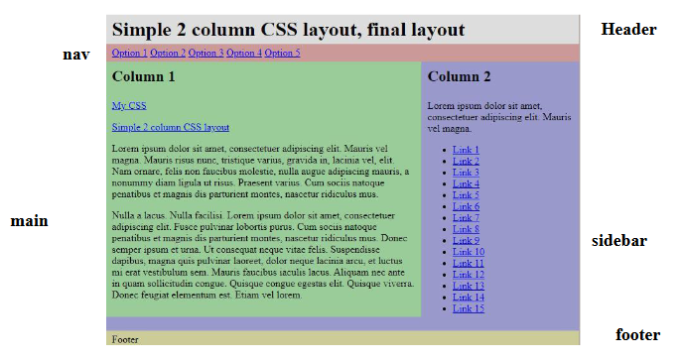

**Steps to be implemented in designing the CSS layout :**

The layout consists of a header, a horizontal navigation bar, a main content column, a sidebar, and footer. It is also horizontally centered in the browser window.

**1. Basic structure**

First of all, we create the basic HTML structure:

| **<div id="wrap">**  **<div id="header"></div>**  **<div id="nav"></div>**  **<div id="main"></div>**  **<div id="sidebar"></div>**  **<div id="footer"></div>**  **</div>** |
| --- |

**2. After that, we put some content in the different sections:**

| **<div id="wrap">**  **<div id="header">**  **Simple 2 column CSS layout, final layout**  **</div>**  **<div id="nav">**  **<ul >**  **<li>**  **<a href="#">**  **option1**  **</a>**  **</li>**  **<li>**  **<a href="#">**  **option2**  **</a>**  **</li>**  **<li>**  **<a href="#">**  **option3**  **</a>**  **</li>**  **<li>**  **<a href="#">**  **option4**  **</a>**  **</li>**  **<li>**  **<a href="#">**  **option5**  **</a>**  **</li>**  **</ul>**  **</div>**  **<div id="main">**  **<h1>**  **Column 1**  **</h1>**  **<p>**  **<a href="#">**  **My CSS**  **</a>**  **</p>**  **<p>**  **<a href="#">**  **Simple 2 column CSS layout, final layout**  **</a>**  **</p>**  **<p>**  **Lorem ipsum dolor sit amet, consectetuer adipiscing elit.**  **Mauris vel mena.**  **Mauris risus nunc, tristique varius, gravida in, lacinia vel, elit.**  **Nam ornare, felis non faucibus molestie, nulla augue adipiscing mauris, a nonummy diam ligula ut risus.**  **Praesent varius Cum sociis natoque penatibus et magnis dis parturient montes, nascetur ridiculus mus**  **Nulla a lacus. Nulla facilisi. Lorem ipsum dolor sit amet, consectetuer adipiscing elit.**  **Fusce pulvinar lobortis purus.**  **Cum sociis natoque penatibus et magnis dis parturient montes, nascetur ridiculus mus. Donec semper ipsum et urna.**  **Ut consequat neque vitae felis. Suspendisse dapibus, magna quis pulvinar laoreet, dolor neque lacinia arcu,**  **et luctus mi erat vestibulum sem Mauris faucibus iaculis lacus. Aliquam nec ante in quam sollicitudin congue Quisque congue egestas elit.**  **Quisque viverra Donec feugiat elementum est. Etiam vel lorem.**  **</p>**  **</div>**  **<div id="sidebar">**  **<h1>**  **Column 2**  **</h1>**  **<p>**  **Lorem ipsum dolor sit amet, consectetuer adipiscing elit.**  **Mauris vel magna.**  **</p>**  **<ul>**  **<li>**  **<a href="#">**  **link1**  **</a>**  **</li>**  **<li>**  **<a href="#">**  **link2**  **</a>**  **<li>**  **<a href="#">**  **link3**  **</a>**  **</li>**  **<li>**  **<a href="#">**  **link4**  **</a>**  **</li>**  **<li>**  **<a href="#">**  **link5**  **</a>**  **</li>**  **<li>**  **<a href="#">**  **link6**  **</a>**  **</li>**  **<li>**  **<a href="#">**  **link7**  **</a>**  **</li>**  **<li>**  **<a href="#">**  **link8**  **</a>**  **</li>**  **<li>**  **<a href="#">**  **link9**  **</a>**  **</li>**  **<li>**  **<a href="#">**  **link10**  **</a>**  **</li>**  **<li>**  **<a href="#">**  **link11**  **</a>**  **</li>**  **<li>**  **<a href="#">**  **link12**  **</a>**  **</li>**  **<li>**  **<a href="#">**  **link13**  **</a>**  **</li>**  **<li>**  **<a href="#">**  **link14**  **</a>**  **</li>**  **<li>**  **<a href="#">**  **link15**  **</a>**  **</li>**  **</ul>**  **</div>**  **<div id="footer">**  **<p>**  **footer**  **</p>**  **</div>**  **</div>** |
| --- |

Now we have a completely unstyled HTML document which is structured in a way that lets us use CSS to control its layout.

**3. Adjust the body and html elements:**

To make the content reach the edges of the browser window, we set the margin and padding of the body and html elements to zero. We also specify colors for text and background.

| **body,html**  **{**  **margin : 0;**  **padding : 0;**  **color : #000;**  **background : #a7a09a;**  **}** |
| --- |

**4. On to the main containers:**

After that it’s time to give the content area a width and center it horizontally. We do that by specifying the width and margins of the main container, #wrap. We also give it a background colour to make it show up on the page.

The method we use to center the content is based on the fact that when an element’s left and right margins are set to auto, they will share whatever is left when the element’s width has been subtracted from that of its container. In this case the width of #wrap will be subtracted from the width of the browser window.

| **#wrap**  **{**  **width : 750px;**  **margin : 0 auto;**  **background : #99c;**  **}** |
| --- |

**5. After that, we give the different sections of the document different background colours to make them show up.**

| **#header {**  **background : #ddd;**  **}**  **#nav {**  **background:#c99;**  **}**  **#main {**  **background:#9c9;**  **}**  **#sidebar {**  **background:#c9c;**  **}**  **#footer {**  **background:#cc9;**  **}** |
| --- |

**6. Place the columns side by side**

To make the two columns (#main and #sidebar) display side by side we float them, one to the left and the other to the right. We also specify the widths of the columns.

| **#main**  **{**  **float:left;**  **width:500px;**  **background:#9c9;**  **}**  **#sidebar**  **{**  **float:right;**  **width:250px;**  **background:#c9c;**  **}** |
| --- |

**7. Push the footer down**

The footer doesn’t get pushed down to the bottom of the content because of the way float works. When you float an element, it is removed from the document flow and doesn’t push elements that follow it down. In this case #footer will start right below #sidebar. To avoid this we use the clear property to tell the footer that it can’t have any elements next to it.

| **#footer { clear:both; background:#cc9;**  **}** |
| --- |

**8. Make the navigation bar horizontal:**

#nav contains a regular unordered list of links. Since we don’t want it to look like an unordered list we restyle it.

| **#nav ul { list-style-type:none;**  **margin:0;**  **padding:0;**  **}**  **#nav li {**  **display:inline;**  **margin:0;**  **padding:0;**  **}** |
| --- |

**9. Adjust margins and paddings, and make IE 6 cooperate:**

Almost done, Time to adjust the margin and padding of some elements to make the layout a little less cramped.

| **#header {**  **padding:5px 10px;**  **background:#ddd;**  **}**  **h1 {**  **margin:0;**  **}**  **#nav {**  **padding:5px 10px;**  **background:#c99;**  **}**  **#main {**  **float:left;**  **width:480px;**  **padding:10px;**  **background:#9c9;**  **}**  **h2 {**  **margin:0;**  **}**  **#sidebar {**  **float:right;**  **width:230px;**  **padding:10px;**  **background:#99c;**  **}**  **#footer {**  **padding:5px 10px;**  **background:#cc9;**  **clear:both;**  **}**  **#footer p {**  **margin:0;**  **}** |
| --- |

**Task 3:**

**Task3: Create the following three column layout using external CSS:**

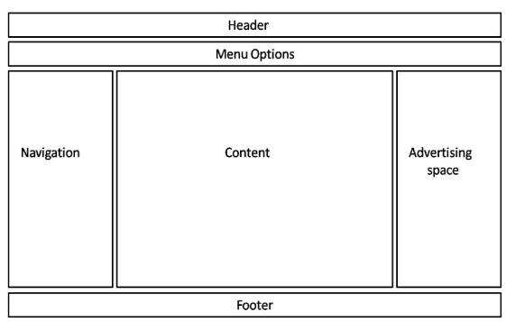

**Program:**

| **<!Doctype html>**  **<head>**  **<meta charset="UTF-8">**  **<title>**  **Task 3**  **</title>**  **<link rel="stylesheet" href="ex1-task3.css">**  **</head>**  **<body>**  **<div id="wrap">**  **<div id="head">**  **<center>**  **<b>**  **Header**  **</b>**  **</center>**    **</div>**  **<div id="menu" >**  **<center>**  **<b>**  **MenuOptions**  **</b>**  **</center>**  **</div>**  **<div id="mainbody">**  **<div id="nav" class="column left">**  **<br>**  **<br>**  **<br>**  **<br>**  **<br>**  **<br>**    **<center>**  **<b>**  **Navigation**  **</b>**  **</center>**  **</div>**  **<div id="con" class="column middle">**  **<br>**  **<br>**  **<br>**  **<br>**  **<br>**  **<br>**  **<center>**  **<b>**  **Content**  **</b>**  **</center>**  **</div>**  **<div id="ad" class="column right">**  **<br>**  **<br>**  **<br>**  **<br>**  **<br>**  **<br>**  **<center>**  **<b>**  **Advertising space**  **</b>**  **</center>**  **</div>**    **</div>**  **<div id='foot'>**  **<center>**  **<b>**  **Footer**  **</b>**  **</center>**  **</div>**  **</div>**  **</body>**  **</html>** |
| --- |

**Output:**

**Task 1:**

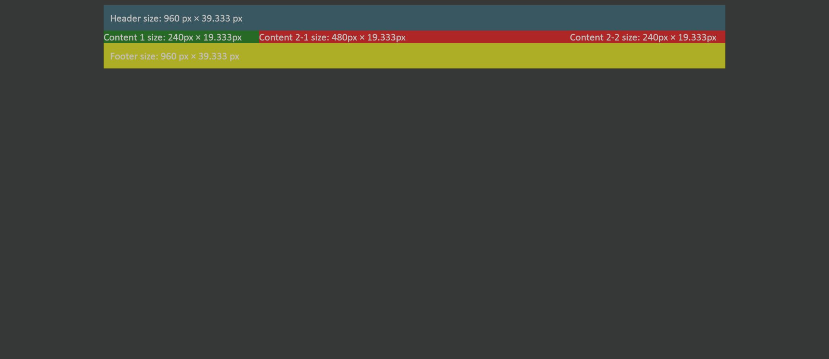

**Task 2:**

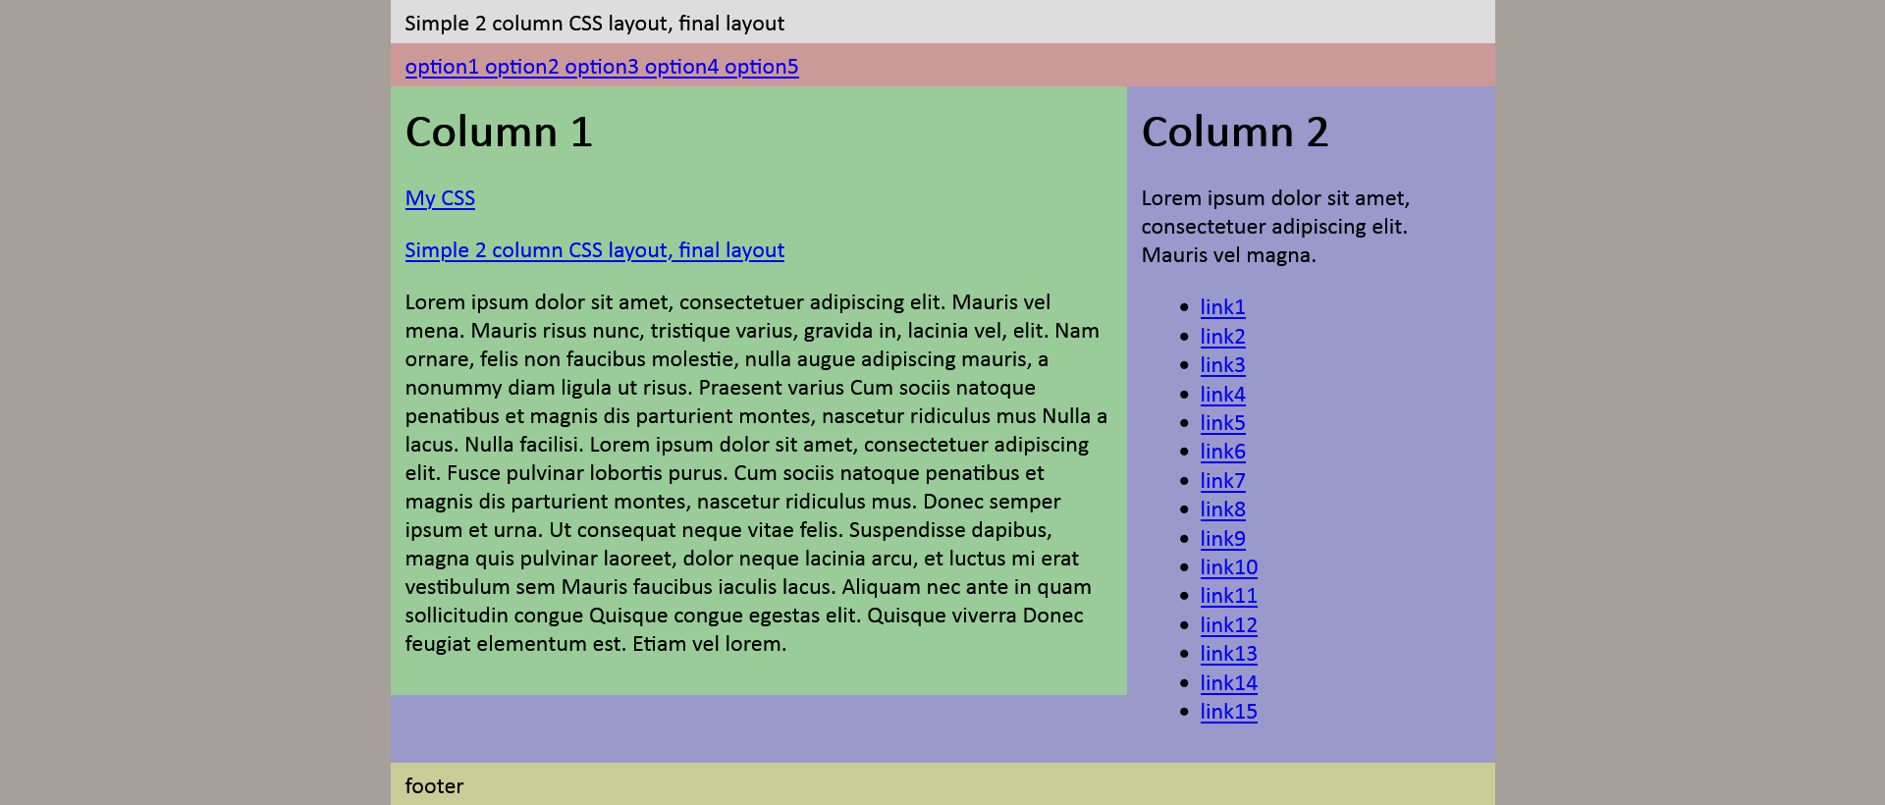

**Task 3:**

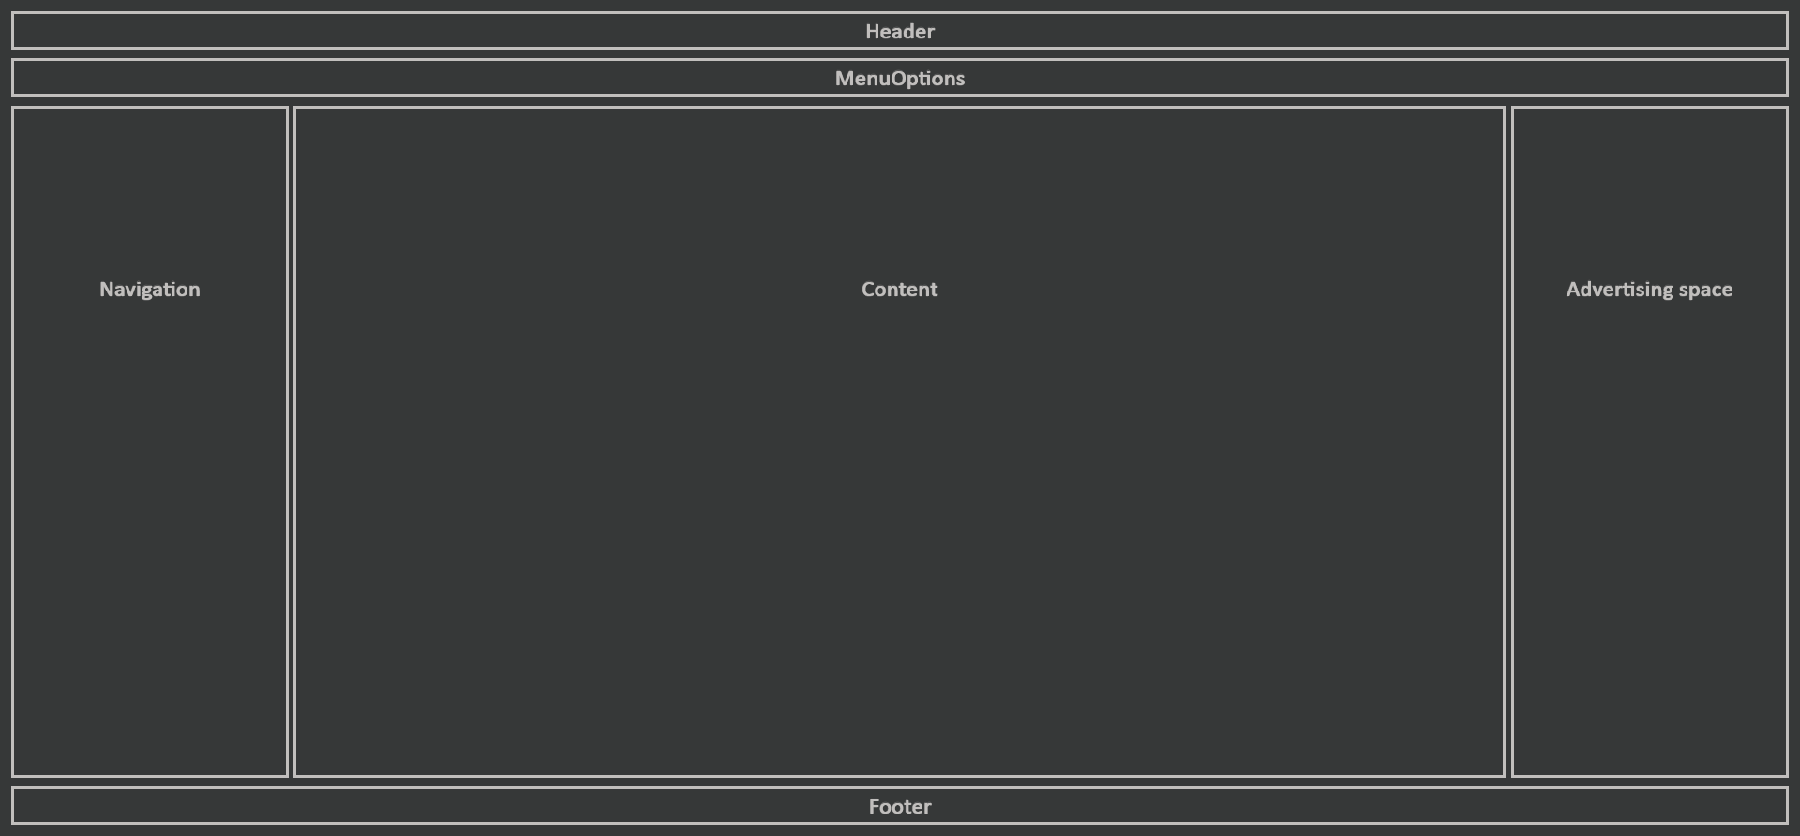

**Result:**

Hence, the code is successfully executed.